6.170 Team se042
Final Project: Gizmoball David Tsai
Eric Tung
Ragu Vijaykumar

Meeting Agenda: 5/8/03

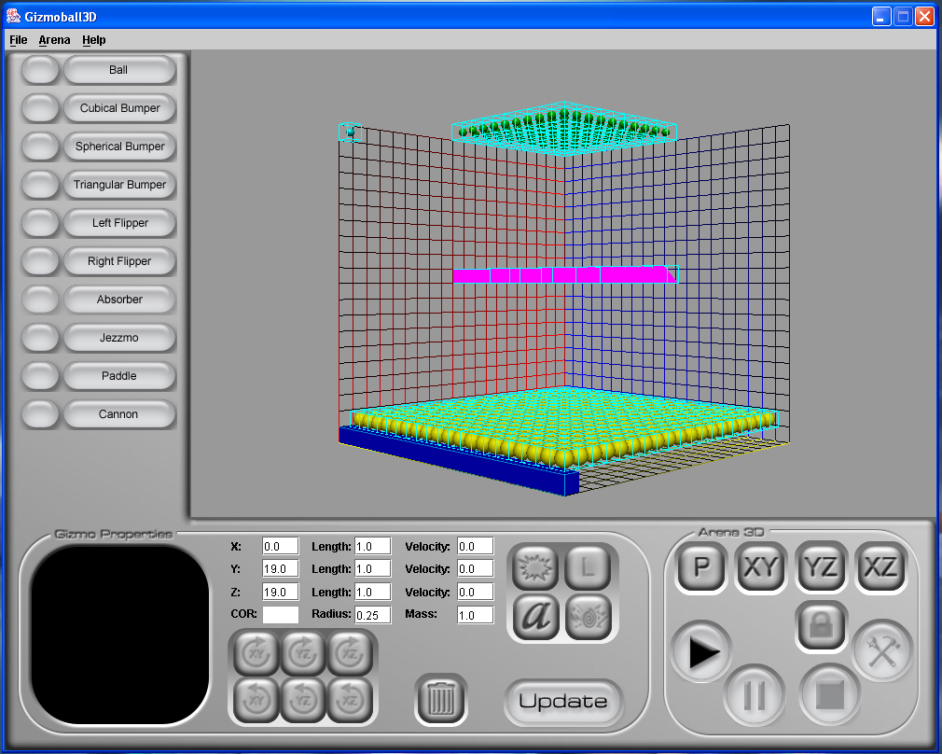
(screenshot from 5/8/03)

Progress since last week
A. Features implemented and issues/bugs solved
a. Majority of GUI artwork completed
b. Graphic bounding boxes no longer detect erroneous collisions
c. Rewrote hash codes and implemented cached hash codes.
d. GUI functionality making slow but steady progress.
e. Fixed some screen scaling issues.
f. Fixed a small mathematical bug with absorbers.
g. Added some basic snap-to-grid, though it is still incomplete/buggy.
h. Gizmos can now accommodate mouse events.
B. Newly resolved design issues
a. Might add a “destructible/indestructible” toggle.
b. Might add sound.
Description of new issues that have been discovered in the past week
A. Bugs and problems
a. Rotation of gizmos unimplemented yet.
b. Flipper physics not working yet.
c. Jezzmos unimplemented yet.
B. Unresolved design issues
a. How to handle location spawning of newly created gizmo
b. How to efficiently handle play/stop mode.
i. Option 1: Caching of all gizmos’ properties.
ii. Option 2: Create a temporary load/save file/string just for
play/stop.

Assessment of success of last weeks’ plan
- A lot of progress made on GUI’s interface in terms of look; functionality still
lacking.
- Flipper and gizmo rotation not fixed yet.
- Several small bugs fixed.
- Basic sound functionality researched; we may or may not use it.

Plan for upcoming week
- Finish all basic requirements.
- Finish amendment requirements.
- Try to optimize as much as we can (i.e. handle 100 ball case).
- If there is time is left, add in “destructibility” option for some gizmos.
- If there is time is left, add a “cannon” gizmo.
- If there is time left, implement sound.
- Create some solid maps to demo.

